Week1

TASK1.1:

Screenshot 1: Submit a screenshot of VS Code & VueJS app running in localhost.

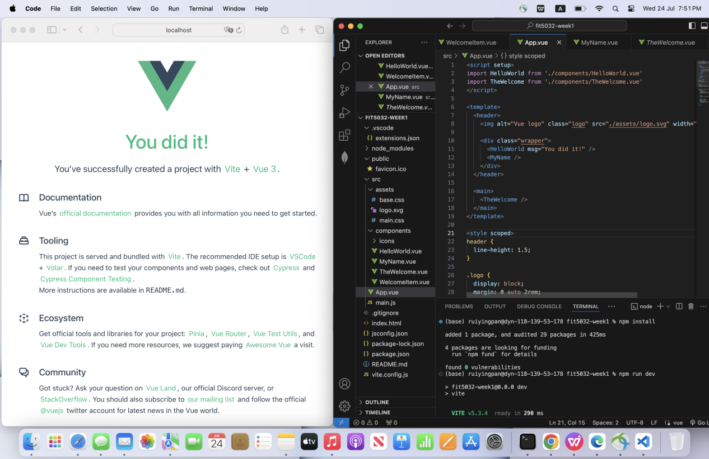

TASK1.2:

Screenshot 2: VS Code (with your MyName.vue file open)

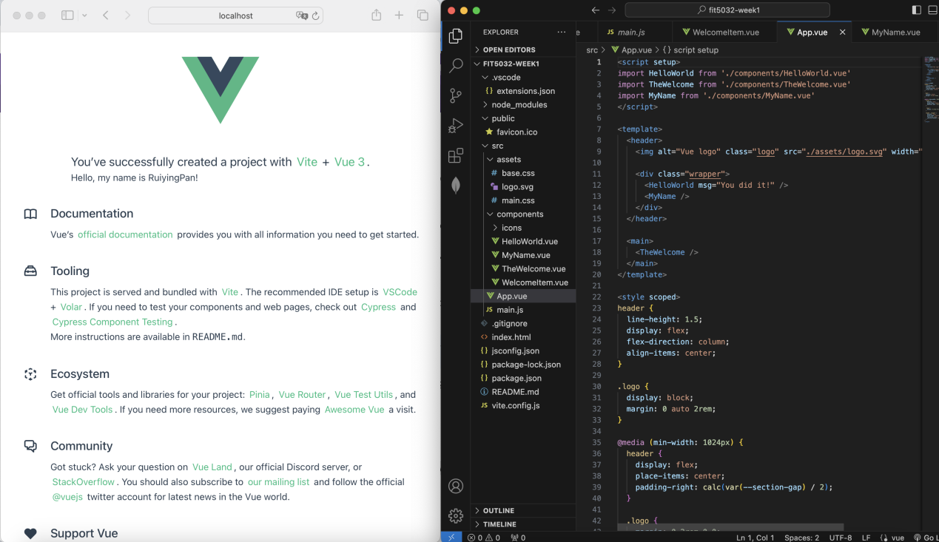

Screenshot 3: the browser window with the modified welcome page which now also shows the output of the MyName.vue component

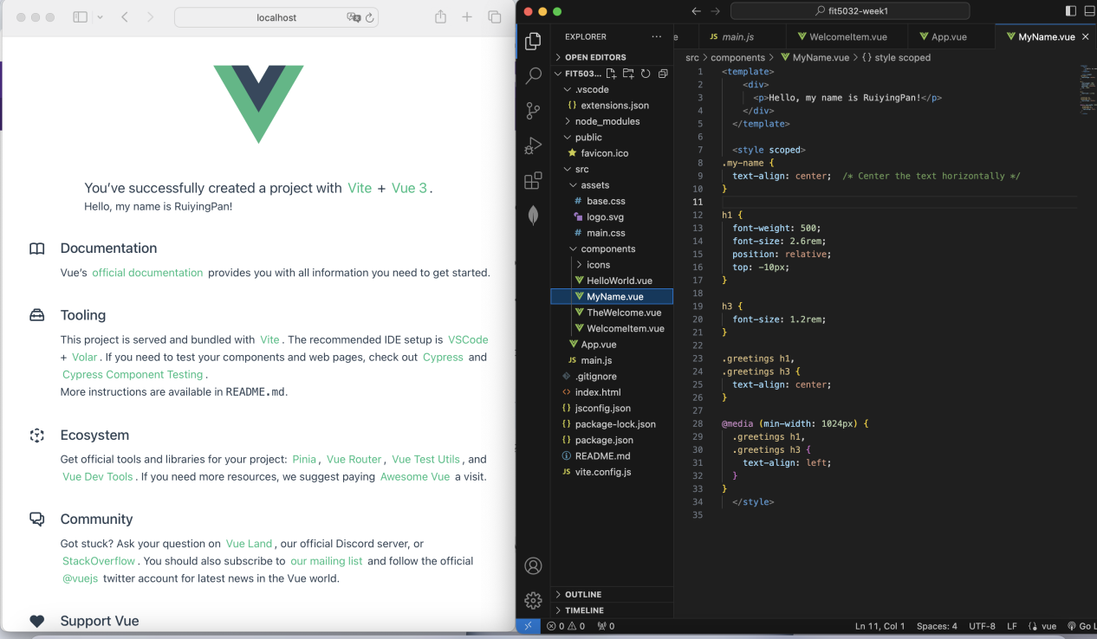

GitHub account URL：

https://github.com/BettyP51

Week2

TASK2.1:

Screenshot 1: Submit screenshots of the VueJS app running with activities 1-13 completed

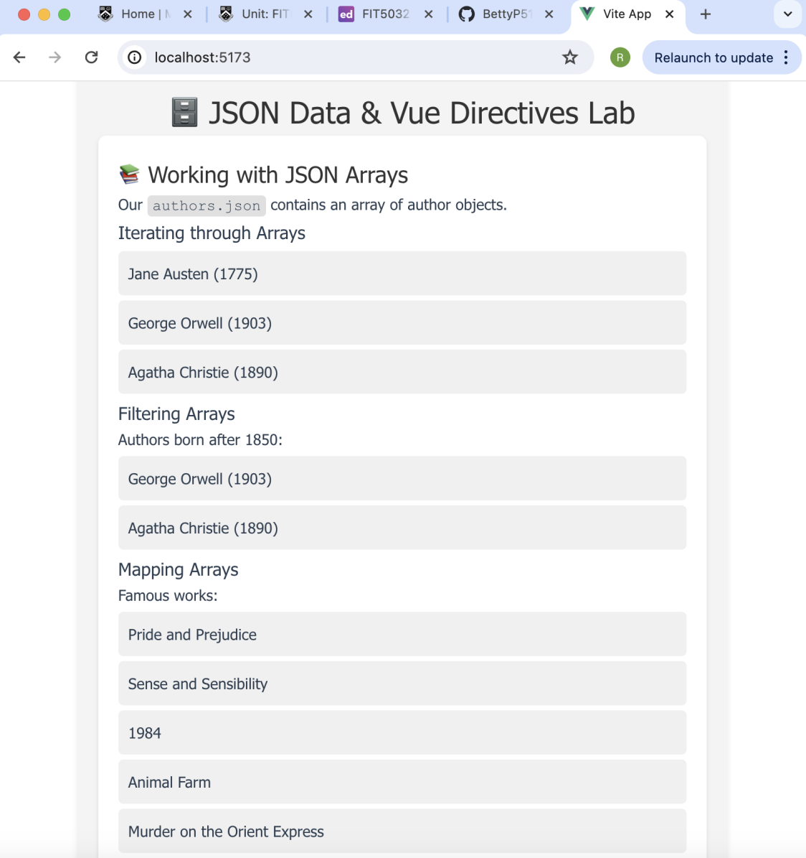

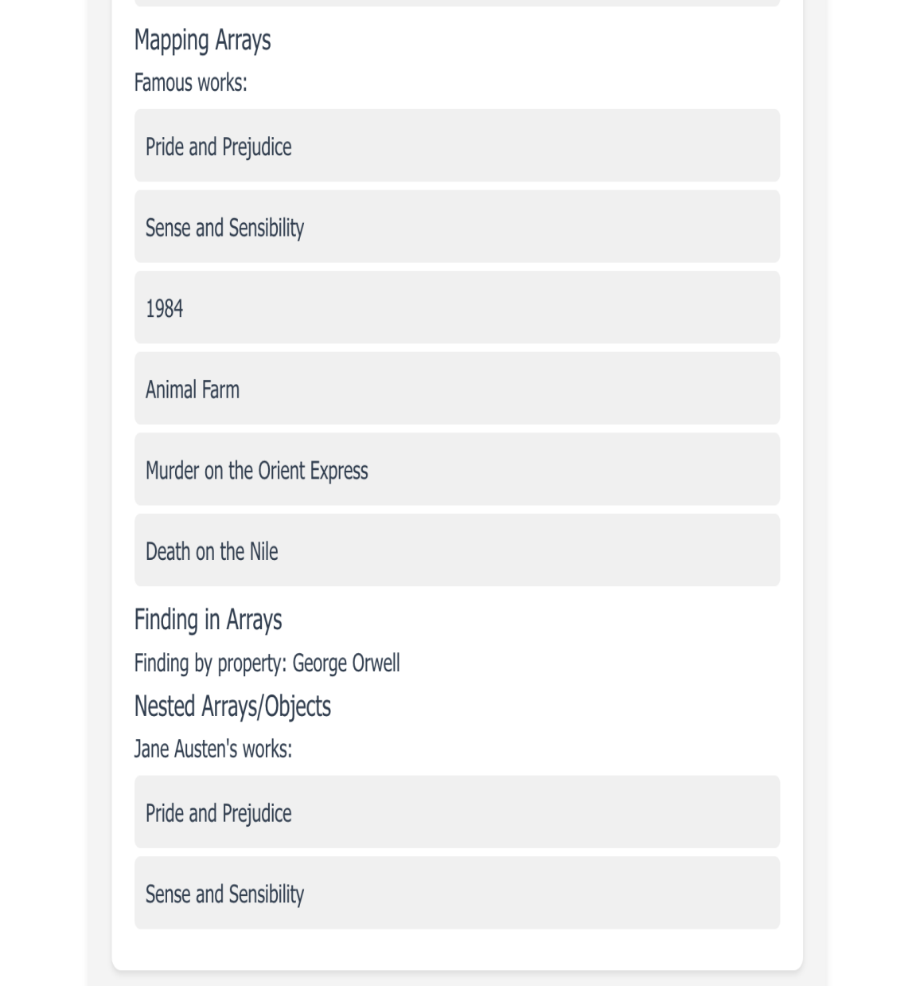

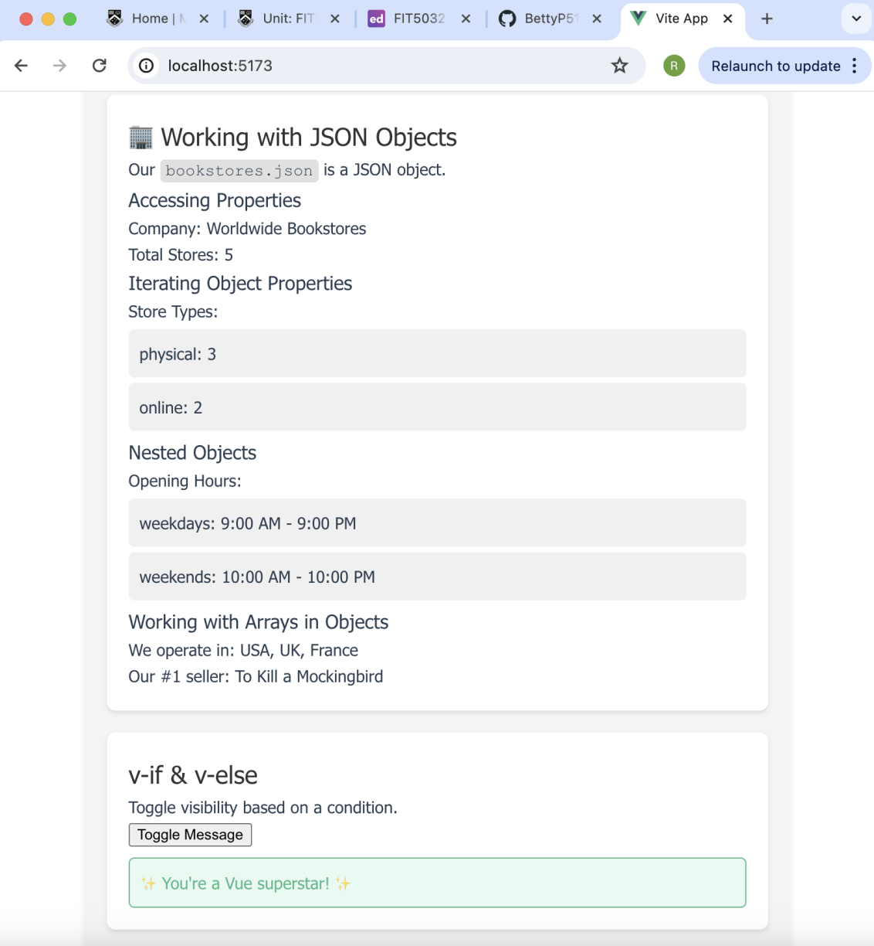

TASK2.2:

screenshot demonstrating the author-highlight functionality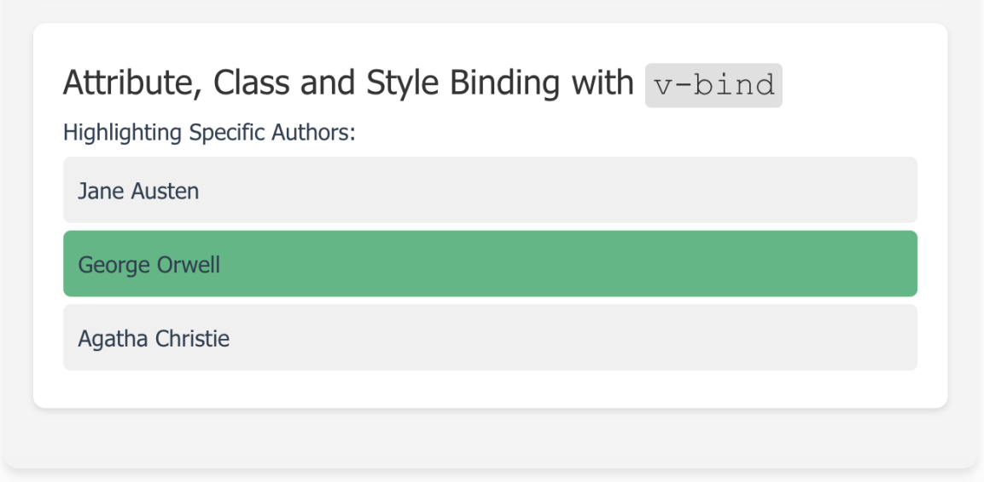

screenshot of the code for implementing the author-highlight functionality

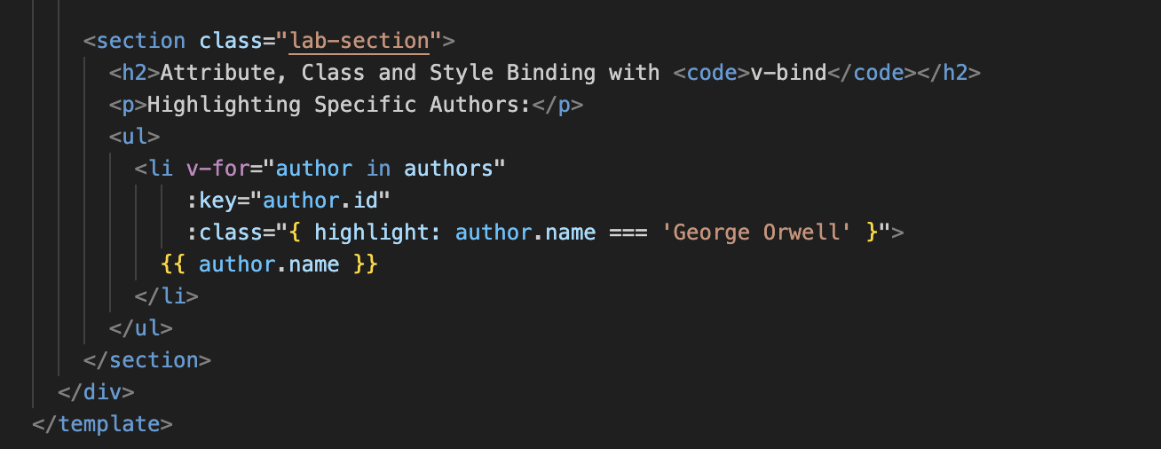

screenshot showing the GitHub history with your project update

